**JQUERY ASSIGNMENT**

1. **Console "Hello Word" in document.ready function.**

**ANS:**

<!DOCTYPE html>

<head>

<title>Ques1</title>

<script src="https://code.jquery.com/jquery-3.3.1.js"

integrity="sha256-2Kok7MbOyxpgUVvAk/HJ2jigOSYS2auK4Pfzbm7uH60="

crossorigin="anonymous"></script>

<meta charset="UTF-8">

</head>

<body>

<h2>Console "Hello Word" in document.ready function</h2>

<script>

$(document).ready(function()

{

console.log("hello world");

})

</script>

</body>

</html>

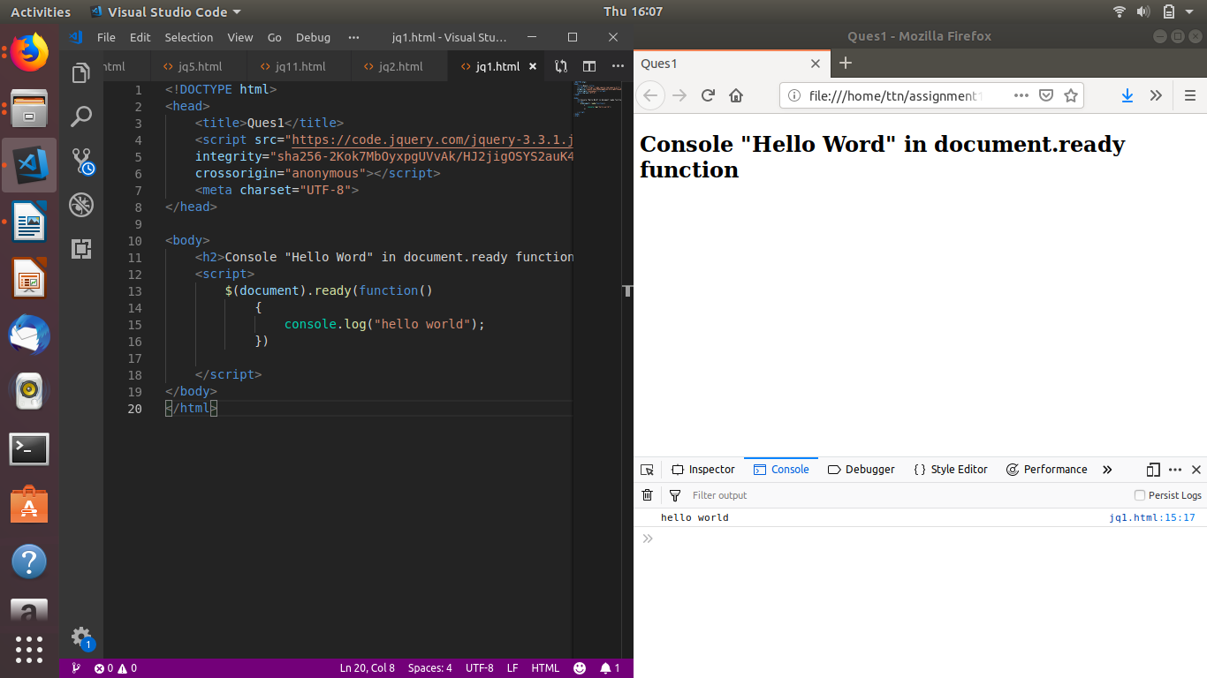

1. **Select a ID name "#test" and add class "load" when DOM is loaded.**

**ANS:**

<!DOCTYPE html>

<head>

<script

src="https://code.jquery.com/jquery-3.3.1.js"

integrity="sha256-2Kok7MbOyxpgUVvAk/HJ2jigOSYS2auK4Pfzbm7uH60="

crossorigin="anonymous"></script>

<meta charset="UTF-8">

</head>

<body>

<p id="test">This is a sample text paragraph</p>

<script>

$(document).ready(function() {

$('p').addClass('pclass');

})

</script>

</body>

</html>

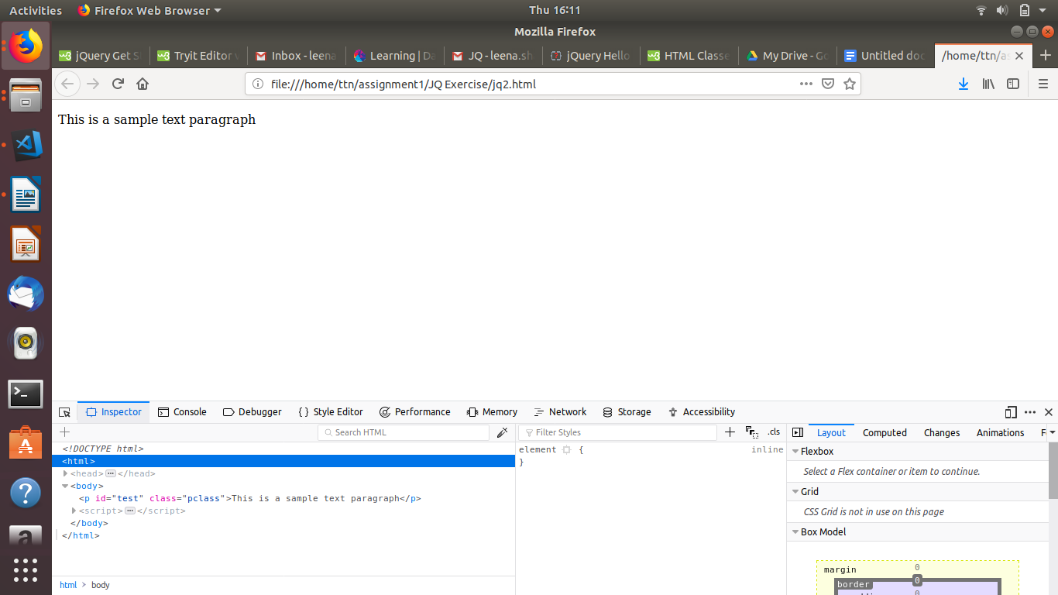

1. **Change the color of element which class name end with "-new".**

**ANS:**

<!DOCTYPE html>

<head>

<script

src="https://code.jquery.com/jquery-3.3.1.js"

integrity="sha256-2Kok7MbOyxpgUVvAk/HJ2jigOSYS2auK4Pfzbm7uH60="

crossorigin="anonymous"></script>

<meta charset="UTF-8">

</head>

<body>

<p class="pnew">This is a sample text para whose class ends with -new</p>

<p class="pold">This is a sample text para whose class ends with -old</p>

<script>

$('[class$=new]').css('color','red');

</script>

</body>

</html>

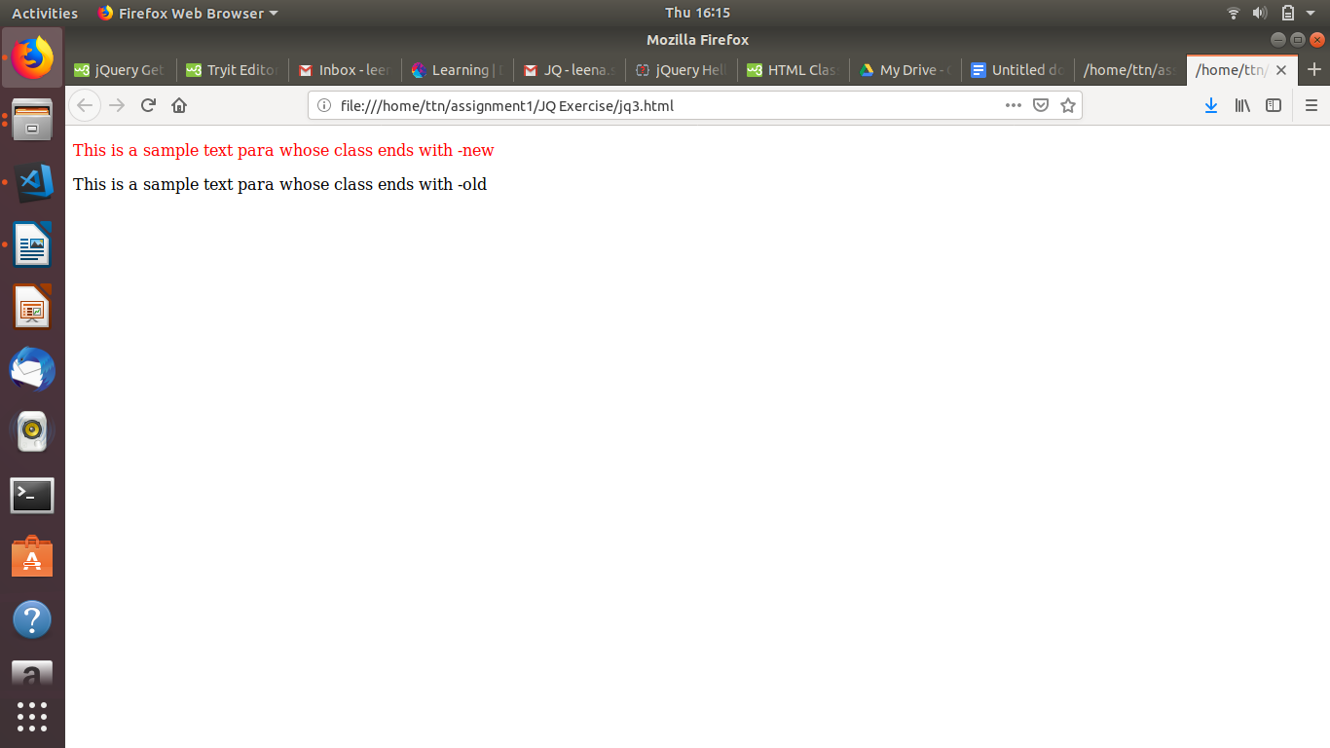

1. **Disable submit button using jquery attr method.**

**ANS.**

<!DOCTYPE html>

<head>

<script

src="https://code.jquery.com/jquery-3.3.1.js"

integrity="sha256-2Kok7MbOyxpgUVvAk/HJ2jigOSYS2auK4Pfzbm7uH60="

crossorigin="anonymous"></script>

<meta charset="UTF-8">

</head>

<body>

<form>

<input type="text" id="t1" placeholder="Enter your name">

<input type="password" id="p1" placeholder="Enter Password">

<button id="b1" type="submit">Submit</button>

</form>

<script>

$('#b1').attr('disabled',true);

</script>

</body>

</html>

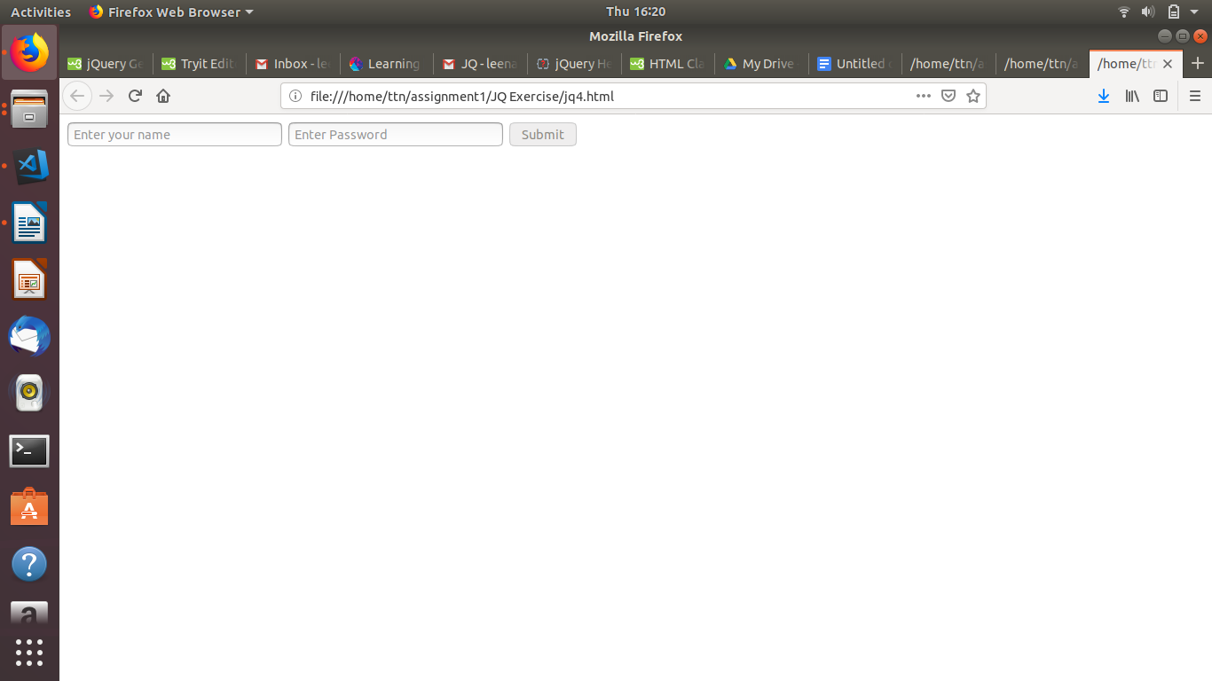

1. **Change the font size of ".target" which has parent element with id name "#main".**

**ANS.**

<!DOCTYPE html>

<head>

<script

src="https://code.jquery.com/jquery-3.3.1.js"

integrity="sha256-2Kok7MbOyxpgUVvAk/HJ2jigOSYS2auK4Pfzbm7uH60="

crossorigin="anonymous"></script>

<meta charset="UTF-8">

</head>

<body>

<div id="main">

<p class="target" style='font-size: 10px'> This is a paragraph with class target.</p>

</div>

<script>

$('#main').children('.target').css('font-size','30px');

</script>

</body>

</html>

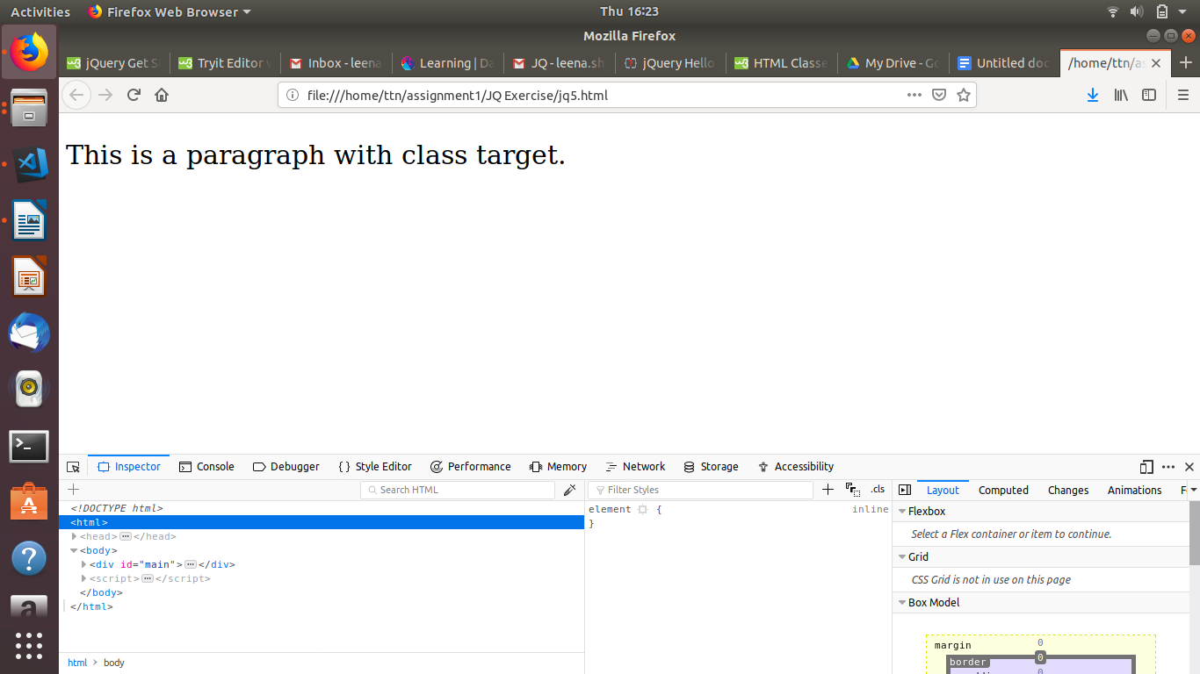

1. **After page load change the HTML of div element with "p" element.**

**ANS.**

<!DOCTYPE html>

<head>

<script

src="https://code.jquery.com/jquery-3.3.1.js"

integrity="sha256-2Kok7MbOyxpgUVvAk/HJ2jigOSYS2auK4Pfzbm7uH60="

crossorigin="anonymous"></script>

<meta charset="UTF-8">

</head>

<body>

<div id="main" style="background-color:red">

<p class="target" style="background-color: rgb(0, 255, 255) " >This is a paragraph with class target.</p>

</div>

<script>

$('#main').html(<p></p>);

</script>

</body>

</html>

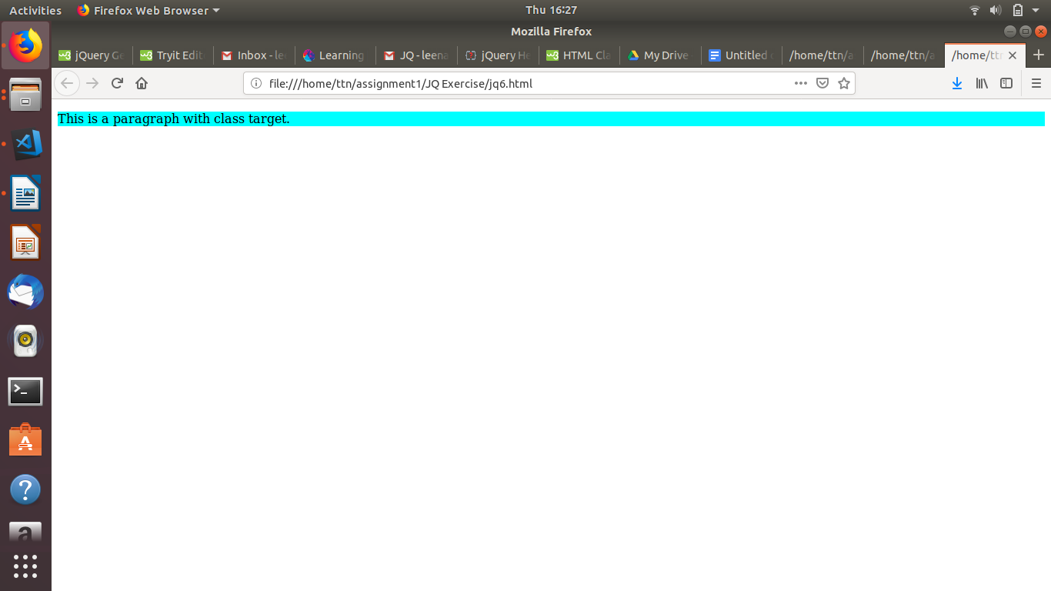

1. **Bind a click function to an "click" element and append next "click" next to it.**

**ANS.**

<!DOCTYPE html>

<html>

<head>

<title>Content Append on Click</title>

<script src="https://ajax.googleapis.com/ajax/libs/jquery/3.3.1/jquery.min.js"></script>

<style>

body {

width: 80%;

margin: 0px auto;

}

div {

color:black;

}

</style>

<script lang="javascript">

$(document).ready(function(){

$("#content").click(function(){

$('#content').append(' click');

});

});

</script>

</head>

<body>

<br />

<div id="content">click</div>

</body>

</html>

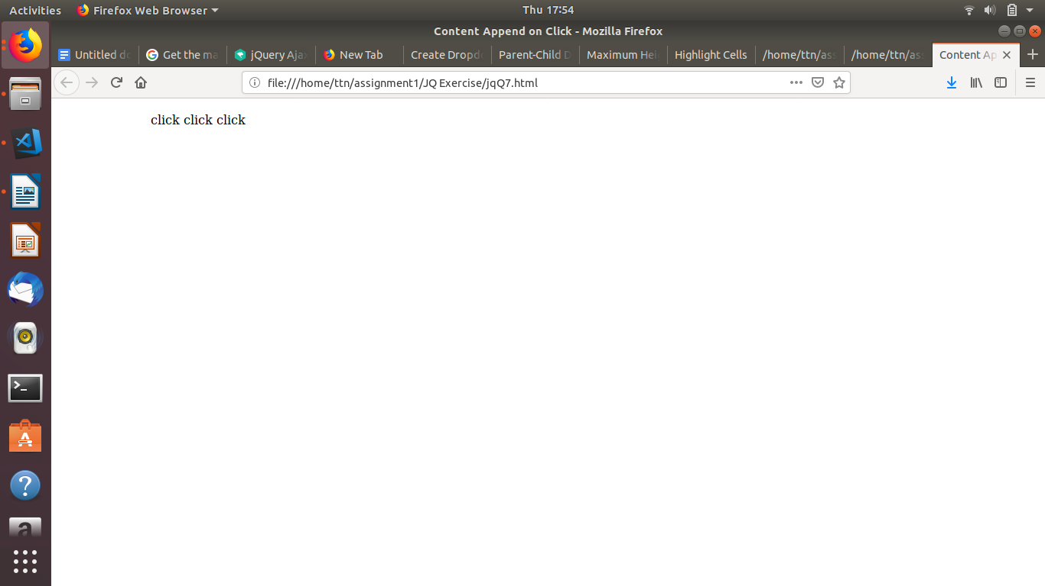

1. **Click event not working on element which added dynamically or via script, make it work using .on method.**

**ANS.**

<!DOCTYPE html>

<html>

<head>

<title>Click Event on Dynamic Elements</title>

<script src="https://ajax.googleapis.com/ajax/libs/jquery/3.3.1/jquery.min.js"></script>

<style>

body {

width: 80%;

margin: 0px auto;

}

p {

color: rgb(172, 71, 255);

font-size: 20px;

}

</style>

<script lang="javascript">

$(document).ready(function(){

$("#message").append('<br /><p id="link">Click Here</p>');

$("#link").on("click", function(e) {

alert('Testing Click Event.');

});

});

</script>

</head>

<body>

<br />

<p id="message">Click Event On Dynamic Contents Like <a> Tag.</p>

</body>

</html>

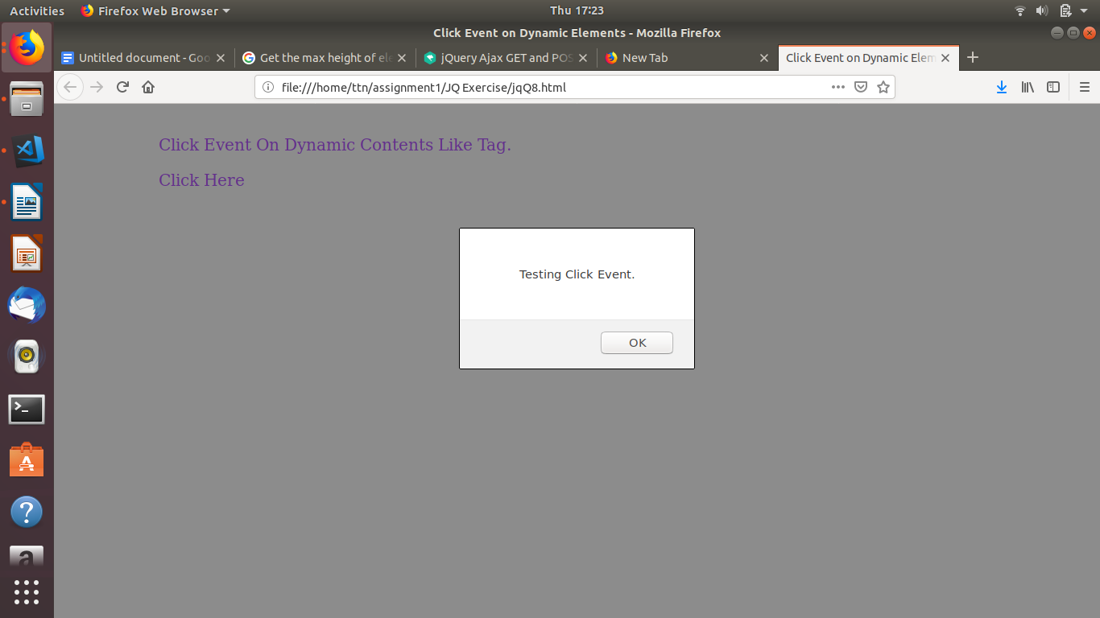

1. **Get dropdown selected value on onchange event and append in div container.**

**ANS.**

<!DOCTYPE html>

<html>

<head>

<title>Dropdown Data Display</title>

<script src="https://ajax.googleapis.com/ajax/libs/jquery/3.3.1/jquery.min.js"></script>

<style>

body {

width: 80%;

margin: 0px auto;

}

p {

color: red;

font-size: 20px;

}

</style>

<script lang="javascript">

$(document).ready(function(){

$("#dd_list").change(function(){

var datalist = $(this).children("option:selected").val();

$("#container").append(datalist+"<br />");

});

});

</script>

</head>

<body>

<br />

<select id="dd_list">

<option id="1">One</option>

<option id="2">Two</option>

<option id="3">Three</option>

<option id="4">Four</option>

<option id="5">Five</option>

<option id="6">Six</option>

</select>

<div id="container">

</div>

</body>

</html>

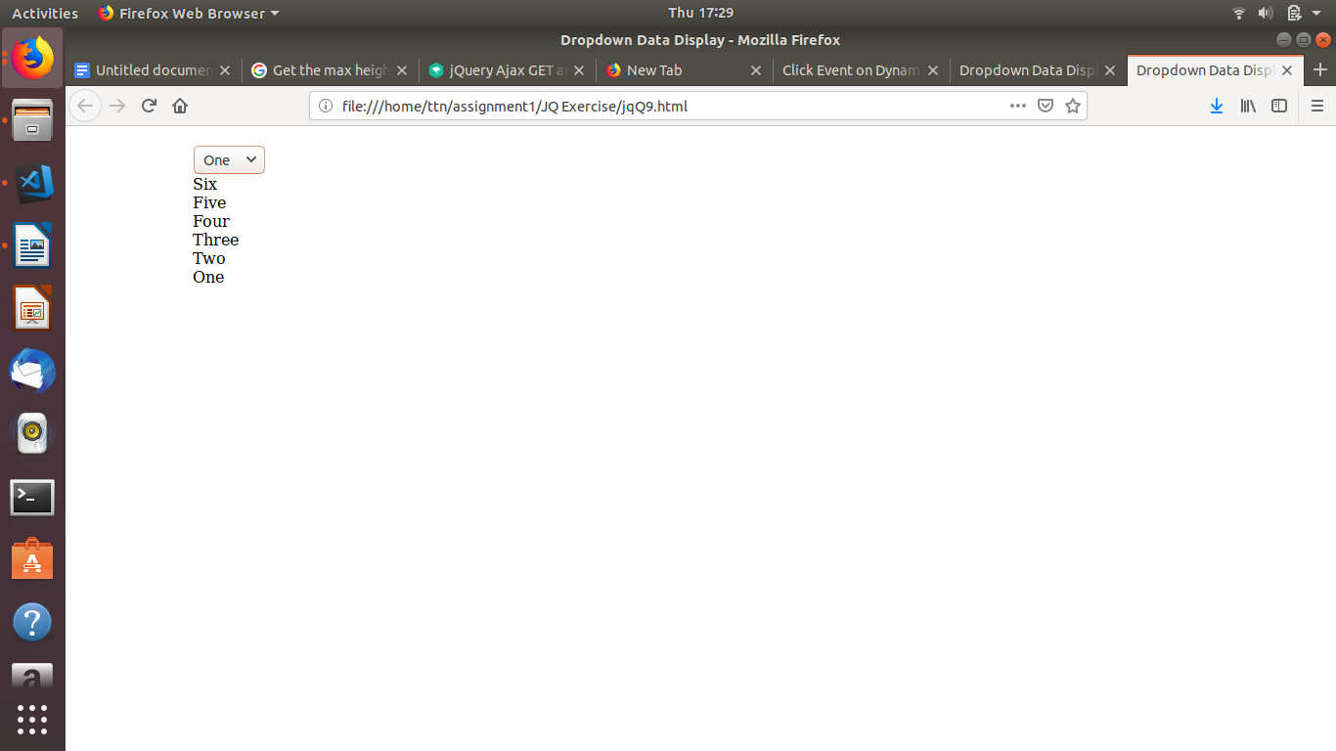

1. **Create a dropdown menu using hover method in jquery.**

**ANS.**

<!DOCTYPE html>

<html>

<head>

<title>Create Dropdown</title>

<script src="https://ajax.googleapis.com/ajax/libs/jquery/3.3.1/jquery.min.js"></script>

<style>

body {

width: 80%;

margin: 0px auto;

}

p {

color: rgb(0, 153, 255);

font-size: 20px;

}

</style>

<script lang="javascript">

$(document).ready(function(){

$('#container').hover(function(e) {

$('body').append("<select name='dd'><option id='1'>first data</option><option id='2'>second data</option></select>");

});

});

</script>

</head>

<body>

<br />

<p id="container">Hover to Create DropDown List</p>

</body>

</html>

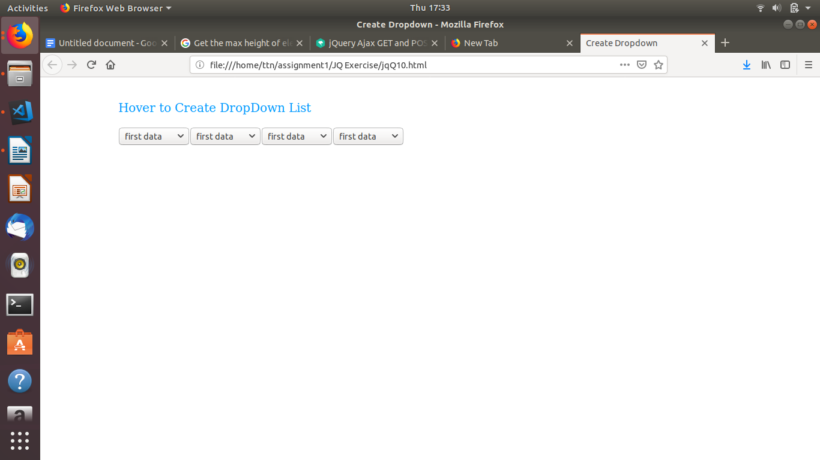

1. **On clicking on "**[**google**](https://www.google.com)**" tag. It is taking us to google home page. Stop it from happening.**

**ANS.**

<!DOCTYPE html>

<head>

<script

src="https://code.jquery.com/jquery-3.3.1.js"

integrity="sha256-2Kok7MbOyxpgUVvAk/HJ2jigOSYS2auK4Pfzbm7uH60="

crossorigin="anonymous"></script>

<meta charset="UTF-8">

</head>

<body>

<a href="http://www.google.com" > Link to Google</a>

<script>

$('a').click(function(d){

d.preventDefault();

});

</script>

</body>

</html>

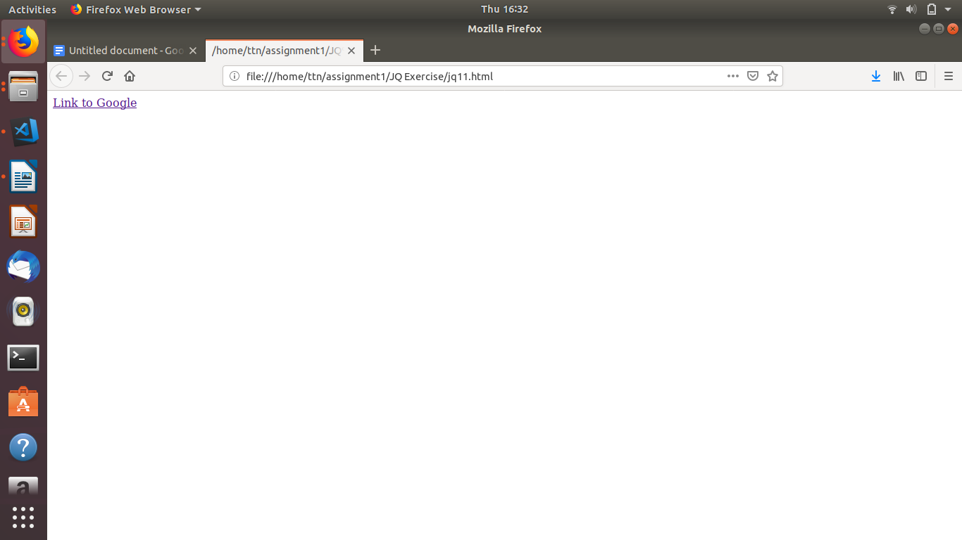

1. **We have bind a click function to parent div but we want stop it from performing when user clicks on its child li.**

**ANS.**

<!DOCTYPE html>

<html>

<head>

<title>Parent-Child Div Click</title>

<script src="https://ajax.googleapis.com/ajax/libs/jquery/3.3.1/jquery.min.js"></script>

<style>

body {

width: 80%;

margin: 0px auto;

}

#parent {

width: 200px;

height: 200px;

background-color: Tomato;

}

#child {

width: 100px;

height: 100px;

background-color: Green;

margin: 50px auto;

}

</style>

<script lang="javascript">

$(document).ready(function(){

$('#parent').on("click", function(e) {

e.stopPropagation();

alert('Parents Clicked!');

});

$('#child').on('click', function(e) {

// clicked on descendant div

e.stopPropagation();

alert('child Clicked!');

});

});

</script>

</head>

<body>

<br />

<div id="parent">This is parent div.

<div id="child">This is child div.

</div>

</div>

</body>

</html>

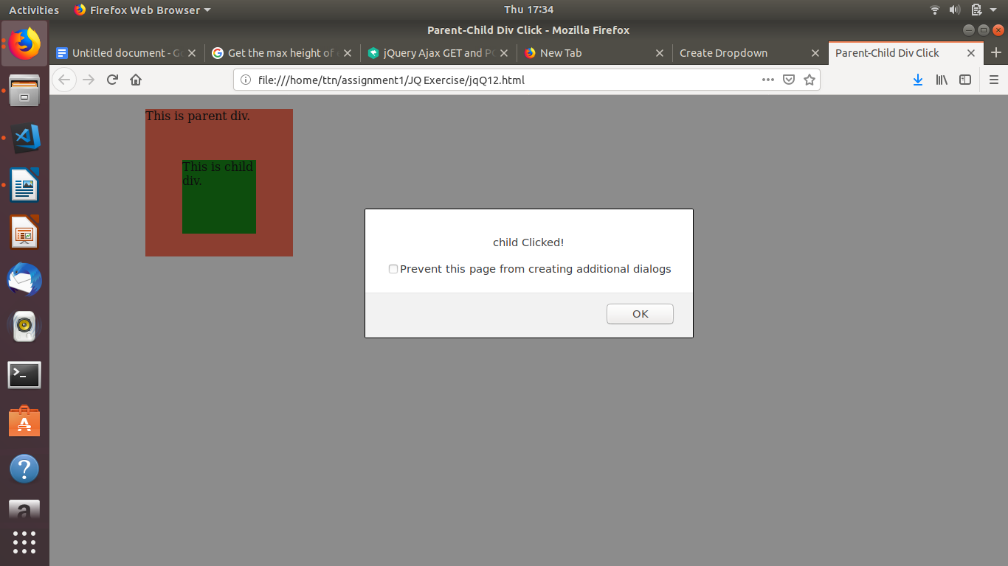

1. **Get the max height of elements using jquery each method.**

**ANS.**

<!DOCTYPE html>

<html>

<head>

<title>Maximum Height of Element</title>

<script src="https://ajax.googleapis.com/ajax/libs/jquery/3.3.1/jquery.min.js"></script>

<style>

body {

width: 80%;

margin: 0px auto;

}

span {

background-color: slateBlue;

color: white;

font-weight: 900;

}

#head {

width: 200px;

height: 110px;

background: Tomato;

}

#content {

width: 200px;

height: 140px;

background: Tomato;

}

#menu {

width: 200px;

height: 150px;

background: Tomato;

}

#foot {

width: 200px;

height: 70px;

background: Tomato;

}

</style>

<script lang="javascript">

$(document).ready(function(){

var large = null;

var hi = 0;

$("div").each(function(){

var h = $(this).height();

if(h > hi){

hi = h;

large = $(this);

}

});

large.css("background-color", "slateBlue");

});

</script>

</head>

<body>

<br />

<p>Element with max height is displayed in <span>slateBlue</span> colour.</p>

<div id="head">

This is head div.<br />Height: 110px

</div>

<div id="content">

This is content div.<br />Height: 140px

</div>

<div id="menu">

This is menu div.<br />Height: 150px

</div>

<div id="foot">

This is foot div.<br />Height: 70px

</div>

</body>

</html>

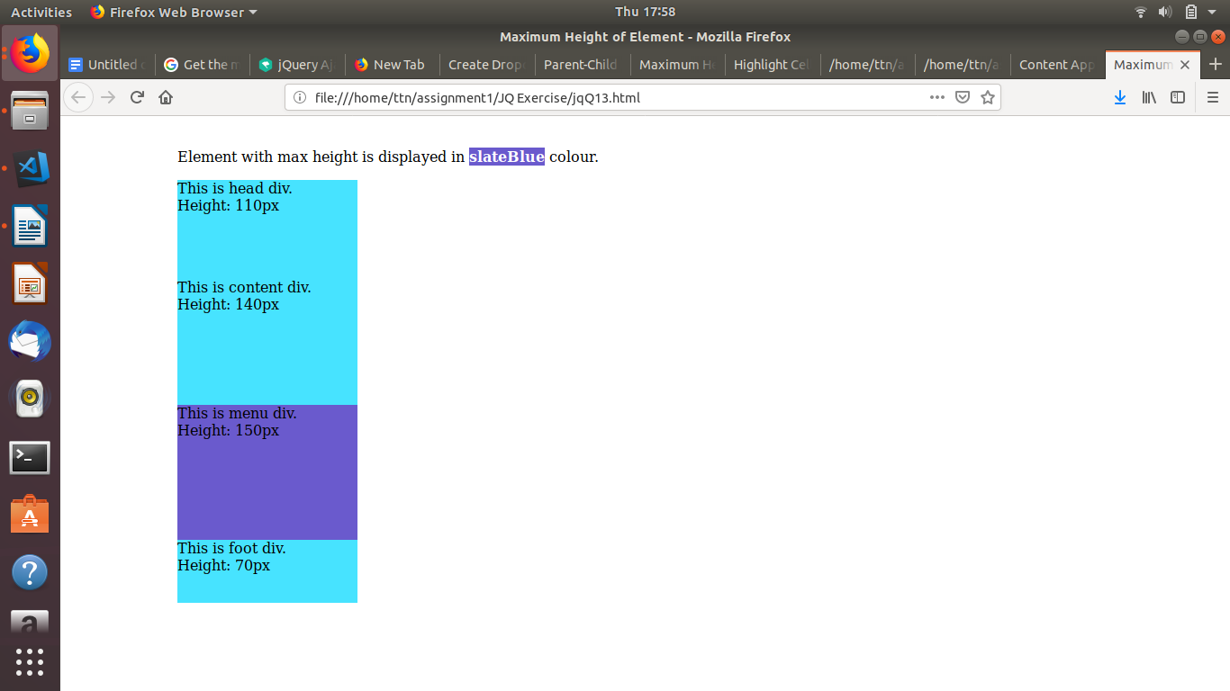

1. **Change color of every cell which has number 1 larger than 10.**

**ANS.**

<!DOCTYPE html>

<html>

<head>

<title>Maximum Height of Element</title>

<script src="https://ajax.googleapis.com/ajax/libs/jquery/3.3.1/jquery.min.js"></script>

<style>

body {

width: 80%;

margin: 0px auto;

}

span {

background-color: slateBlue;

color: white;

font-weight: 900;

}

#head {

width: 200px;

height: 110px;

background: Tomato;

}

#content {

width: 200px;

height: 140px;

background: Tomato;

}

#menu {

width: 200px;

height: 150px;

background: Tomato;

}

#foot {

width: 200px;

height: 70px;

background: Tomato;

}

</style>

<script lang="javascript">

$(document).ready(function(){

var large = null;

var hi = 0;

$("div").each(function(){

var h = $(this).height();

if(h > hi){

hi = h;

large = $(this);

}

});

large.css("background-color", "slateBlue");

});

</script>

</head>

<body>

<br />

<p>Element with max height is displayed in <span>slateBlue</span> colour.</p>

<div id="head">

This is head div.<br />Height: 110px

</div>

<div id="content">

This is content div.<br />Height: 140px

</div>

<div id="menu">

This is menu div.<br />Height: 150px

</div>

<div id="foot">

This is foot div.<br />Height: 70px

</div>

</body>

</html>

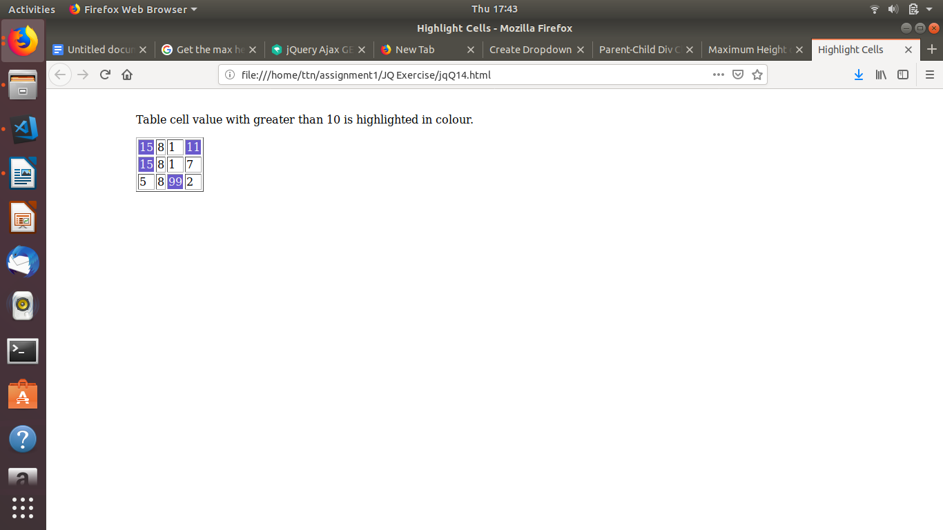

1. **Retrive the data from server using ajax get call.**

**ANS.**

<!DOCTYPE html>

<html>

<head>

<script src="https://ajax.googleapis.com/ajax/libs/jquery/3.3.1/jquery.min.js"></script>

<script>

$(document).ready(function(){

$("button").click(function(){

$.ajax({url: "https://jsonplaceholder.typicode.com/todos/1", success: function(result){

$("#div1").html(JSON.stringify(result));

}});

});

});

</script>

</head>

<body>

<div id="div1"><h2>Let jQuery AJAX Change This Text</h2></div>

<button>Get External Content</button>

</body>

</html>

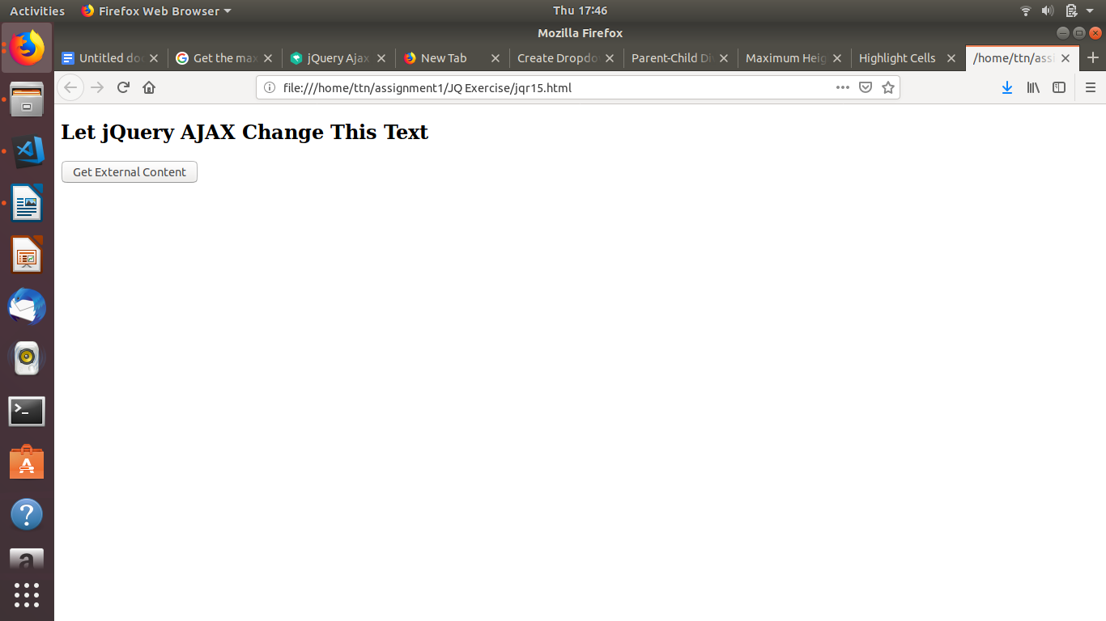

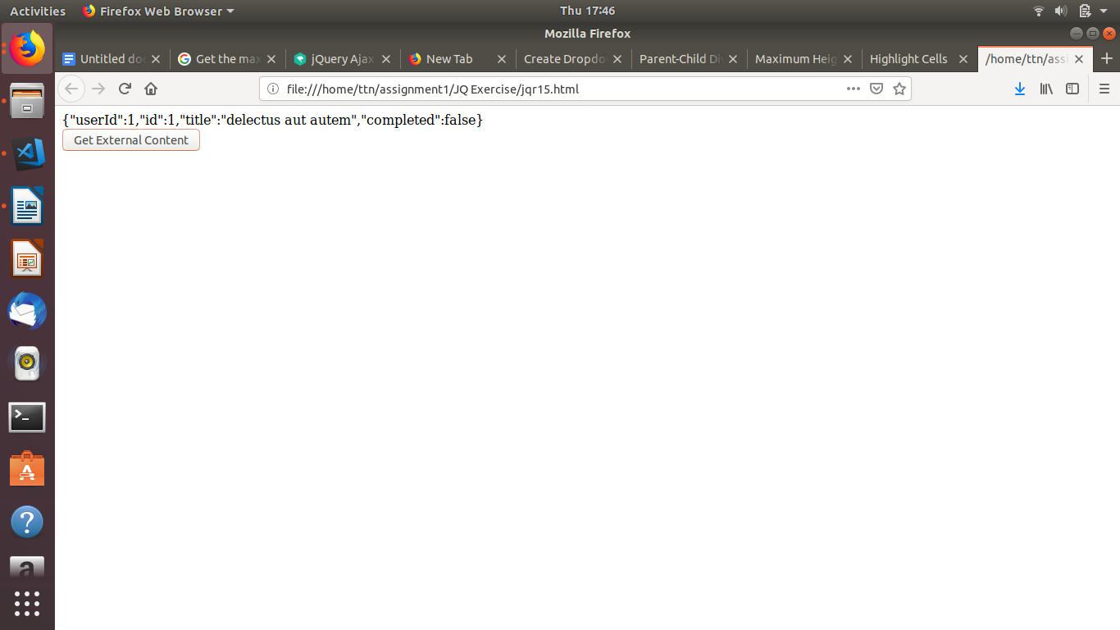

1. **Add cross button on row and bind click function which make a delete request to server, after success event remove the row from dom.**

**ANS.**

<!DOCTYPE html>

<html>

<head>

<meta charset="utf-8">

<title></title>

</head>

<body>

<table border="1">

<tr id="row1">

<td>

abc

</td>

<td>

<input type="button" value="X" id="1">

</td>

</tr>

<tr id="row2">

<td>def</td>

<td>

<input type="button" value="X" id="2">

</td>

</tr>

</table>

<script src="https://ajax.googleapis.com/ajax/libs/jquery/3.3.1/jquery.min.js"></script>

<script lang="javascript">

$(document).ready(function () {

$(":button").click(function(){

bid=$(this).attr("id");

bid="#row"+bid;

$.ajax({url:"https://jsonplaceholder.typicode.com/todos/1",success: function(result){

$(bid).remove();

}});

});

});

</script>

</body>

</html>

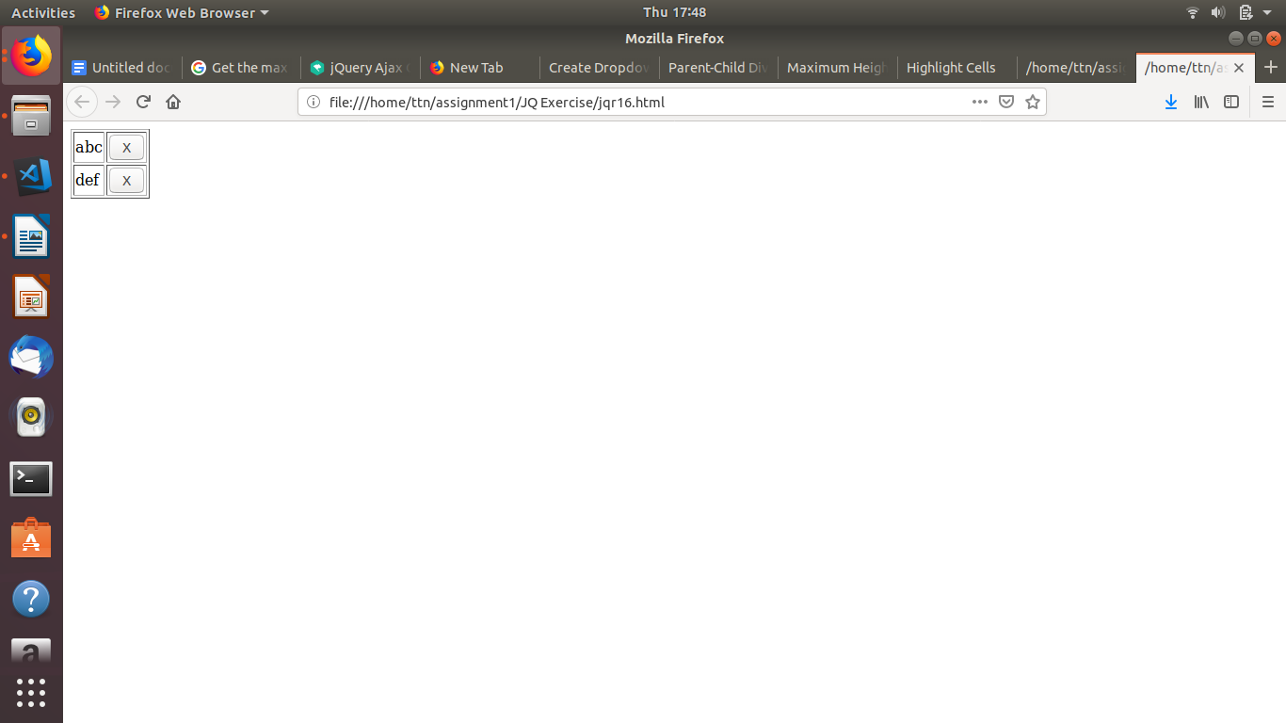

1. **Create a image array and in div create a slide show to animate images of delay of 500ms.**

**ANS.**

<!DOCTYPE html>

<html>

<head>

<title>Image Slider</title>

<script src="https://ajax.googleapis.com/ajax/libs/jquery/3.3.1/jquery.min.js"></script>

<style>

body {

width: 80%;

margin: 0px auto;

}

div {

background-size: auto;

background-position: center;

width: 500px;

height: 500px;

}

</style>

<script lang="javascript">

var array = new Array("slide1.png","slide2.png","slide3.png","slide4.png");

$(document).ready(function(){

var i = 0;

$("#slider").css("background-image", "url(" + array[i] + ")");

setInterval(function () {

i++;

if (i == array.length) {

i = 0;

}

$("#slider").fadeOut("slow", function () {

$(this).css("background-image", "url(" + array[i] + ")");

$(this).fadeIn("slow");

});

}, 500);

});

</script>

</head>

<body>

<br />

<div id="slider"></div>

</body>

</html>

__________________________________________________________________________